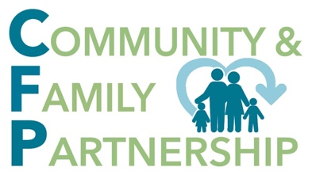
Email Funding Requests to:

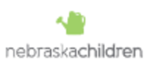
Roberta Miksch, Collective Impact Director
rmiksch@columbusunitedway.com
Office: 402-564-5661
Cell: 402-809-3297
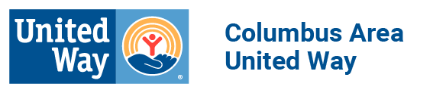
Locations:
1119 B Street
Schuyler, NE
3214 25th St, Ste 2
Columbus, NE

COMMUNITY AND FAMILY PARTNERSHIP FUNDING REQUEST

CRITERIA FOR ELIGIBILITY

A. The applicant’s primary geographical area of service and physical location must be in the
Community and Family Partnership service area (Platte, Colfax, Boone and Nance counties).

B. Requests for support must be consistent with the mission of the Community and Family Partnership (CFP): To assist children, youth, and families to be healthy and resilient through a prevention network of community resources.

C. A representative from the funding recipient program or agency will be asked to attend bi-monthly Community Collaborative meetings hosted by the Community and Family Partnership. These meetings are the first Wednesday of the month at 9:30 am (please refer to CFP Director for further information). The purpose of these meetings are to network with other agencies, identify community needs, and to work on community initiatives identified by the Collaborative.

D. Funding recipients will be allowed to seek extended funding beyond the first year of funding. This does not, however, obligate the Leadership Board to fund the reapplication but only to consider its request. To be eligible for consideration for a second period of funding, the organization must meet the following criteria.
1. Demonstrated effectiveness of the applicant’s program in meeting the proposed
community need.
2. A clear and operable plan for generating other resources. The Community and Family Partnership encourages applicants to avoid an over dependence on only a few grant sources.
3. A financial/program report from the preceding year.

E. Community and Family Partnership funding requests will be considered on an annual basis and are subject to funds avaliable at the time of application.

FUNDING REQUEST TIMELINE

The application and approval procedure is as follows:

1. The applicant must submit the Cover Sheet, Proposal Summary, and Program Budget.

2. The requests will be reviewed by the Leadership Board as submitted and will then make a final determination at their regularly scheduled monthly board meeting.

3. Applicants will be notified of funding approval or denial within one week following the Leadership Board Meeting.

4. The above described time frame can be waived or altered at the discretion of the Leadership Board.

5. A report describing the progress of the applicant’s program will be required six months and twelve months after the distribution of funds.

6. If this is an emergent request (funding needed before the upcoming monthly board meeting), please notify the CFP Coordinator immediately with the desired date of funding and accomodations can be made accordingly.

COMMUNITY AND FAMILY PARTNERSHIP
FUNDING REQUEST

Cover Sheet

Organization ______________________________________________________________

Mailing Address ____________________________________________________________
City State Zip Code

Staff Contact Person _________________________________________________

Title _________________________________________________

Phone Number __________________________

Email Address ______________________________________________________________

Signature ___________________________________ Date___________________________

If funded, to whom would “Pay to the order” need to be listed as: _______________________

PROPOSAL SUMMARY

Please type a brief response DIRECTLY BELOW each question. Send the completed form to the CFP Director at rmiksch@columbusunitedway.com

Program Name:

Program Start/End Dates, if applicable:

Brief Program Description (including the purpose/objective and target population):

What is the community need for the program?

How will program results be evaluated (ex. survey)?

Who is invested in the program with funding, time, other resources, or in kind services?

Do other agencies in the community offer a similar program?

Have you requested CFP funding in the past for this program? If yes, when and how much?

How will you continue the program after the one-year grant funding?

Total Amount Requested:

**Please attach a program budget.

